NAME : G.Karthik reddy ROLL NO : 2403A510F8
ASSIGNMENT : 9.1 SUBJECT : AI ASSISTED CODING

Task Description #1 (Documentation – Google-Style Docstrings for Python Functions)
- Task: Use AI to add Google-style docstrings to all functions in a given Python script.
- Instructions:
- Prompt AI to generate docstrings without providing any input-output examples.
- Ensure each docstring includes:
- Function description
- Parameters with type hints
- Return values with type hints
- Example usage
- Review the generated docstrings for accuracy and formatting.
- Expected Output #1:
- A Python script with all functions documented using correctly formatted Google-style docstrings

PROMPT :
WRITE A PYTHON SCRIPT TO ADD Google-style docstrings to all functions IT SHOULD CONTAIN :
Function description
- Parameters with type hints
- Return values with type hints
- Example usage

CODE GENERATED :

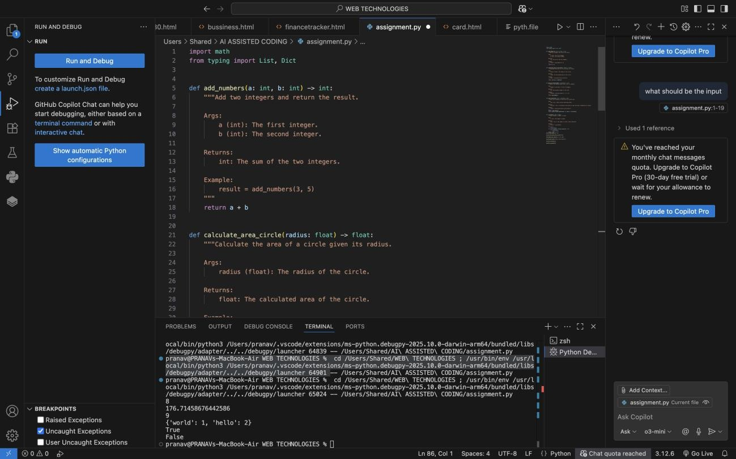
OUTPUT :

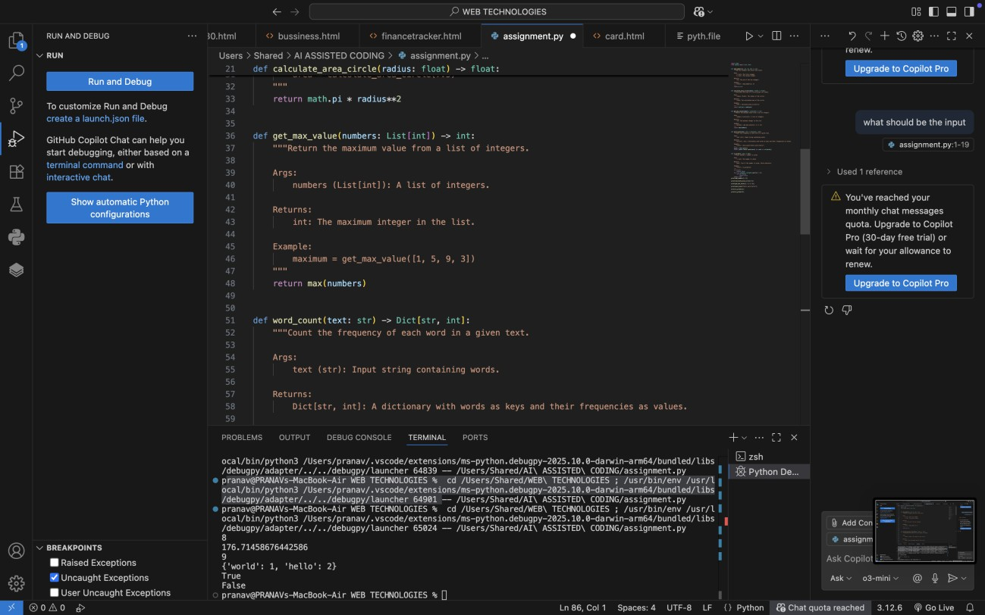

Observation for the Code

- The script defines five independent functions, each performing a specific task:
  - add_numbers(a, b) → Adds two integers.
  - calculate_area_circle(radius) → Computes the area of a circle using the
formula πr².
  - get_max_value(numbers) → Finds the maximum element from a list of
integers.
  - word_count(text) → Returns a dictionary of word frequencies from a given
string.
  - is_prime(n) → Checks if a number is prime.
- Each function is documented with Google-style docstrings, which include:
  - Function description.
  - Parameters with type hints.
  - Return type with description.
  - Example usage for clarity.
- The code uses type hints (int, float, List[int], Dict[str, int], bool) to improve readability and make it easier to catch type-related errors.
- The script imports standard libraries only (math for π and square root, and typing
for type hints).
- The script is written in a modular way:
  - Functions can be reused independently in other programs.
  - Running the script directly will not produce output (since no main block or print statements are included).
- The code is clean, well-documented, and beginner-friendly, making it easy to extend or integrate into larger projects.

Task Description #2 (Documentation – Inline Comments for Complex Logic)
- Task: Use AI to add meaningful inline comments to a Python program explaining only complex logic parts.
- Instructions:
- Provide a Python script without comments to the AI.
- Instruct AI to skip obvious syntax explanations and focus only on tricky or non-intuitive code sections.

- Verify that comments improve code readability and maintainability.
- Expected Output #2:
- Python code with concise, context-aware inline comments for complex logic blocks

PROMPT USED :
Write a code to add meaningful inline comments to a python program explaining only complex logic parts .
Explain only complex structured syntac and usage on tricky or non intuitive code sections

CODE GENERATED :
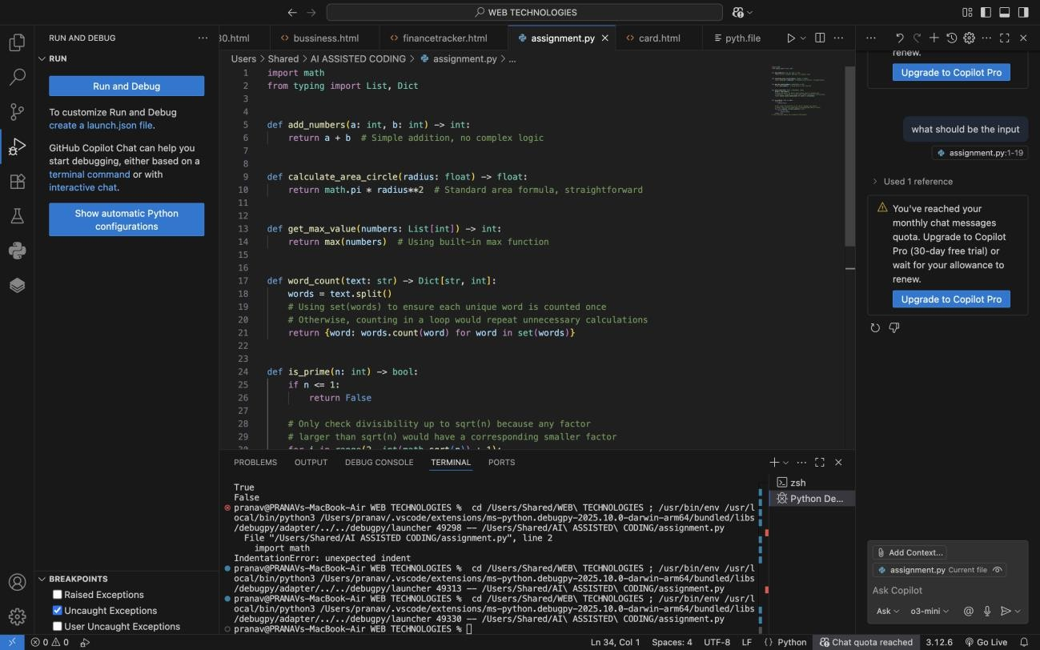

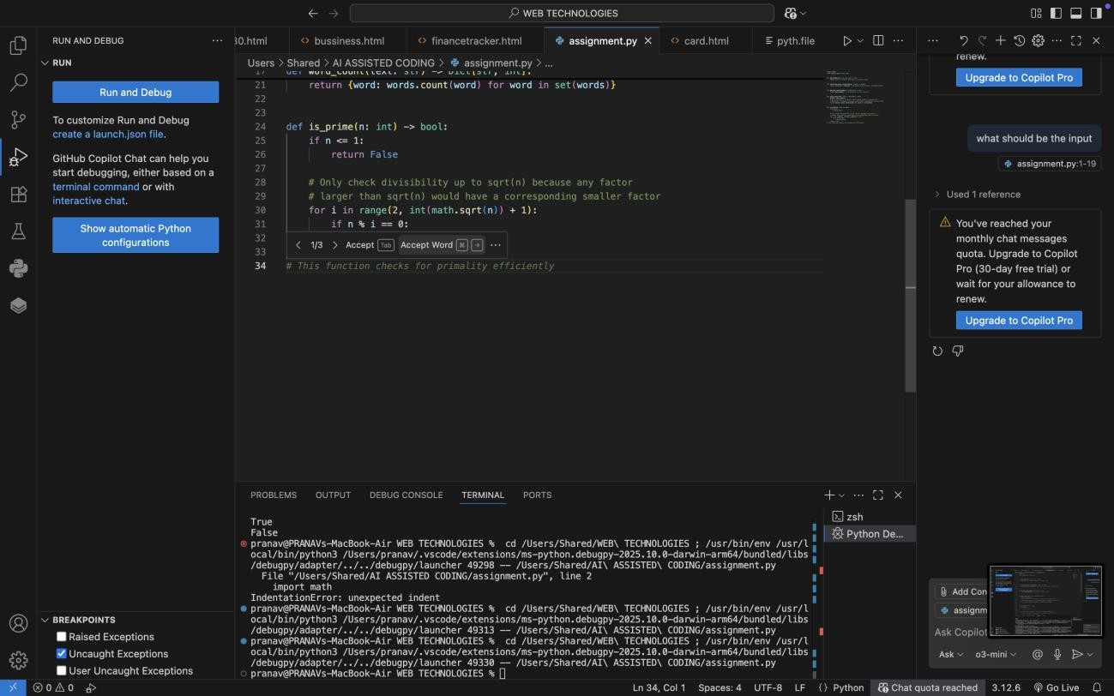

OBSERVATIONS : 1.
The Python script was analyzed to identify non-intuitive or complex logic blocks, ignoring obvious syntax and straightforward statements.
- Inline comments were added directly above or beside lines of code where the reasoning might not be immediately clear, improving code readability and maintainability.
- Examples of complex logic that were commented include:
  - In word_count, using set(words) to avoid redundant counting of the same word multiple times.
  - In is_prime, checking divisibility only up to sqrt(n) for efficiency, since any factor larger than sqrt(n) would have a corresponding smaller factor.
- Obvious operations, like return a + b or return max(numbers), were intentionally not commented, keeping the code clean and concise.
- The added comments help a future developer or reviewer understand why certain approaches were used without cluttering the code with unnecessary explanations.

- Overall, the code is now more maintainable, self-explanatory for complex sections, and easier to debug or extend in the future.

Task Description #3 (Documentation – Module-Level Documentation)
- Task: Use AI to create a module-level docstring summarizing the purpose, dependencies, and main functions/classes of a Python file.

- Instructions:
- Supply the entire Python file to AI.
- Instruct AI to write a single multi-line docstring at the top of the file.
- Ensure the docstring clearly describes functionality and usage without rewriting the entire code.
- Expected Output #3:
- A complete, clear, and concise module-level docstring at the beginning of the file.

PROMPT USED :
WRITE A PURPOSE , DEPENDENCIES, MAIN FUNCTIONS/CLASSES OF A PYTHON FILE WHICH IS ALREADY EXISTING
Write a single multi-line docstring at the top of the file.

CODE GENERATED :

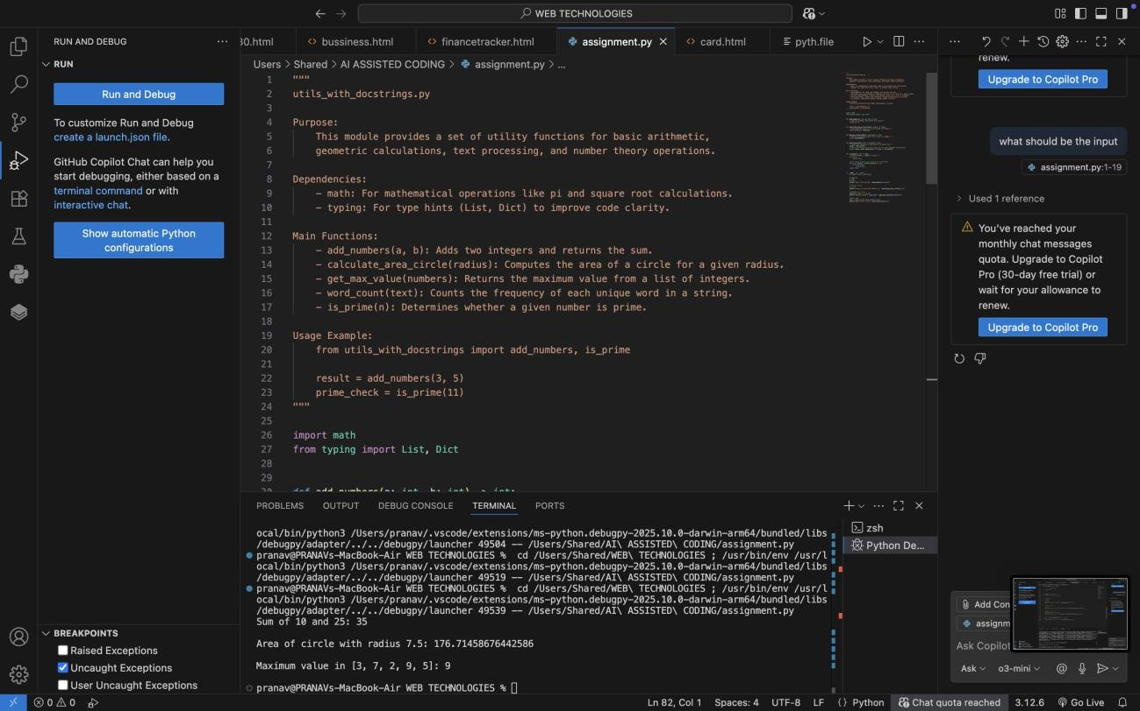
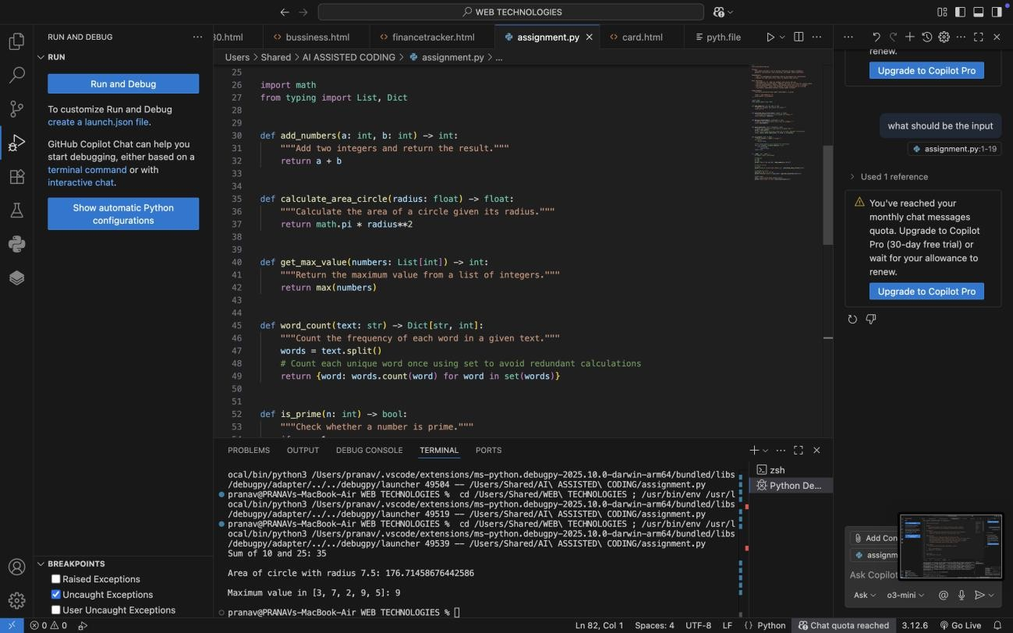

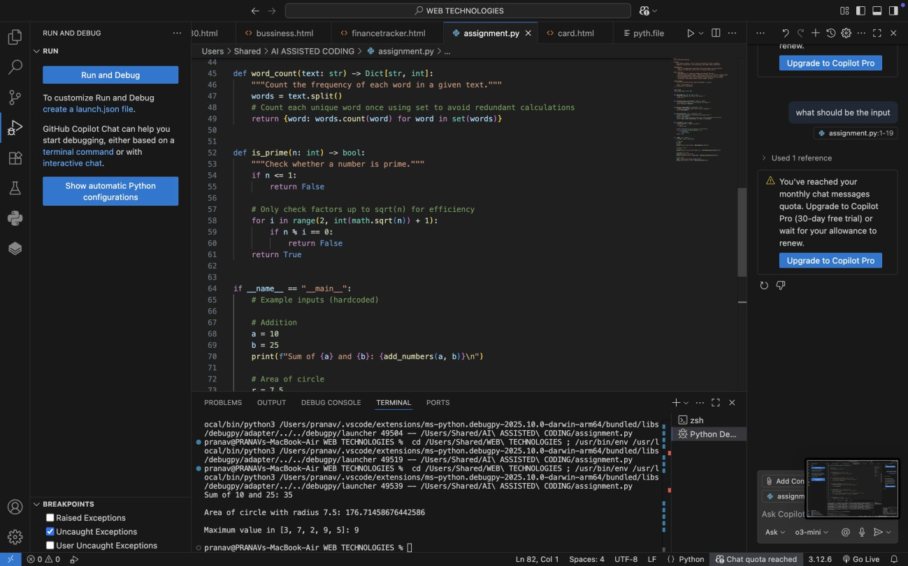
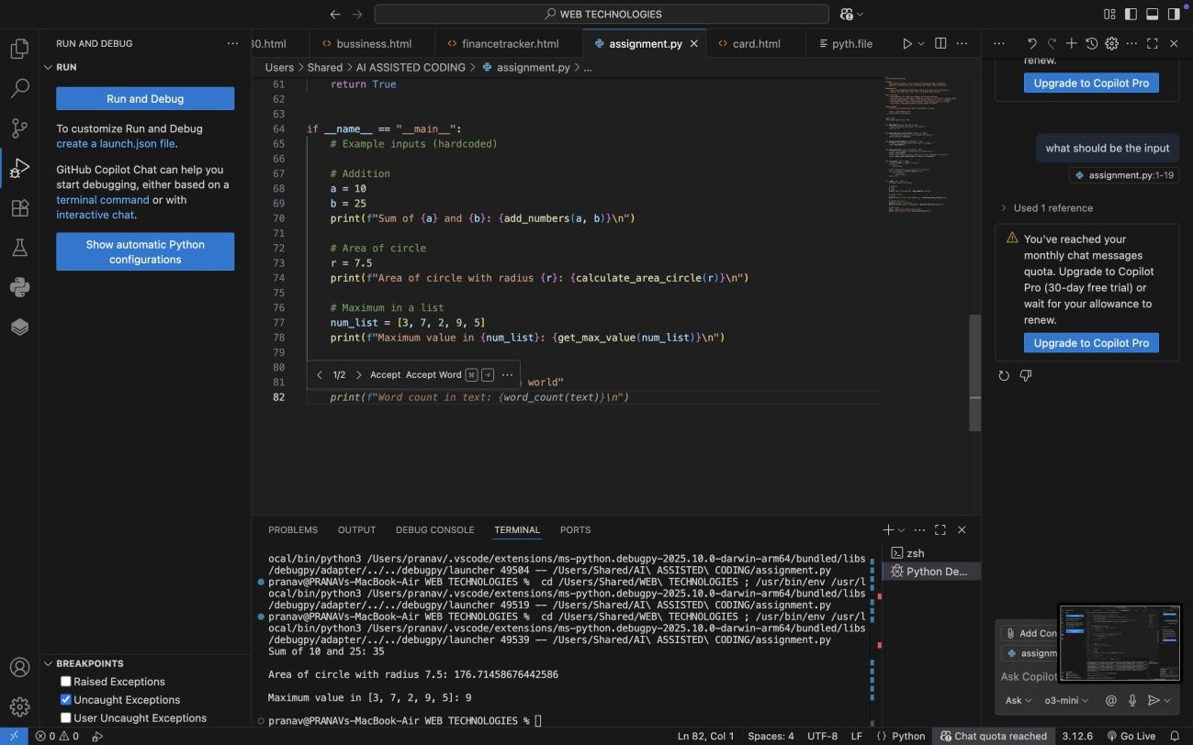
OUTPUT GENERATED :

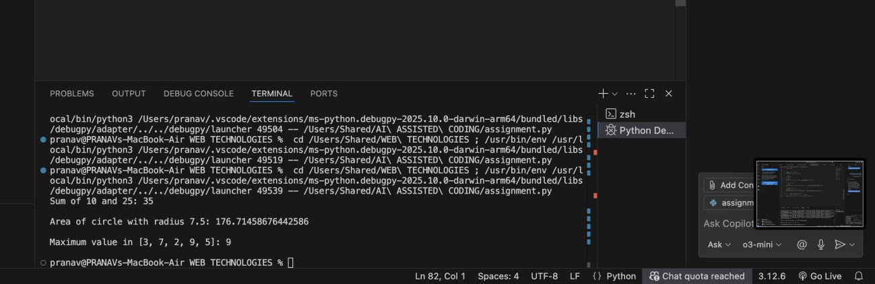

Task Description #4 (Documentation – Convert Comments to Structured Docstrings)
- Task: Use AI to transform existing inline comments into structured function docstrings following Google style.
- Instructions:
- Provide AI with Python code containing inline comments.
- Ask AI to move relevant details from comments into function docstrings.
- Verify that the new docstrings keep the meaning intact while improving structure.
- Expected Output #4:
- Python code with comments replaced by clear, standardized docstrings

PROMPT USED :
WRITE A structured function docstrings using existing inline comments Comments to be changed to function docstrings.

CODE GENERATED :

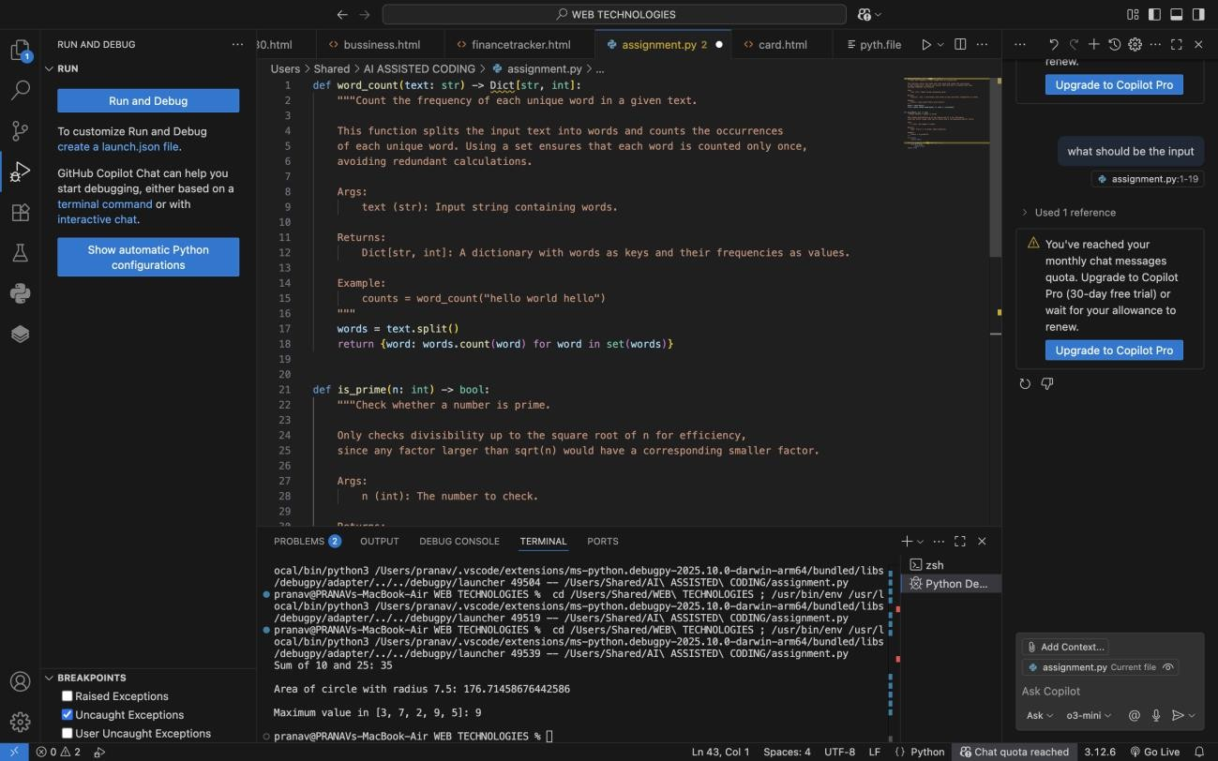

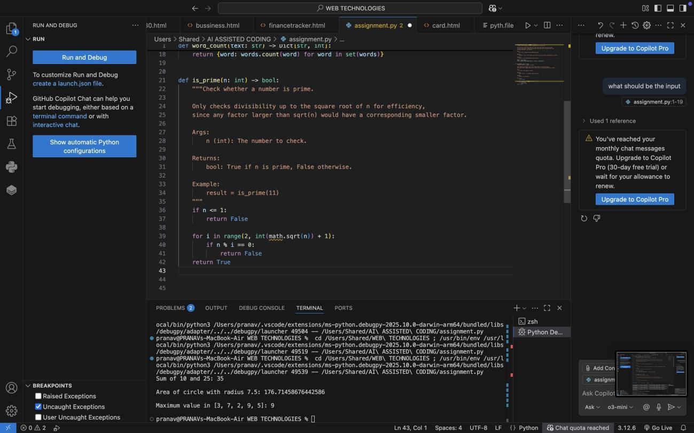

OBSERVATIONS:
  - The given Python file originally contained inline comments to explain non- trivial logic (e.g., using set(words) in word_count and checking factors up to sqrt(n) in is_prime).
  - These inline comments were transformed into structured Google-style docstrings, placed directly inside the functions.
  - Each docstring now provides:
  - A clear description of the function’s purpose.
  - Parameter definitions with type hints.
  - The return type and meaning.
  - An example usage for clarity.
  - Redundant inline comments were removed to keep the code clean and avoid duplication, while still retaining all the meaningful explanations.
  - This improved the readability and maintainability of the code by standardizing documentation in one place (docstrings), making it easier for future developers and tools (like IDEs or documentation generators) to understand the module.
  - Overall, the code is now self-documented, professional, and aligned with best practices for Python documentation.

Task Description #5 (Documentation – Review and Correct Docstrings)
- Task: Use AI to identify and correct inaccuracies in existing docstrings.
- Instructions:
- Provide Python code with outdated or incorrect docstrings.
- Instruct AI to rewrite each docstring to match the current code behavior.
- Ensure corrections follow Google-style formatting.

- Expected Output #5:
- Python file with updated, accurate, and standardized docstrings

PROMPT USED :
To identify and correct inaccuracies in existing docstrings.
Ensure corrections follow Google-style formatting.

OUTDATED OR INACCURATE DOCSTRINGS :
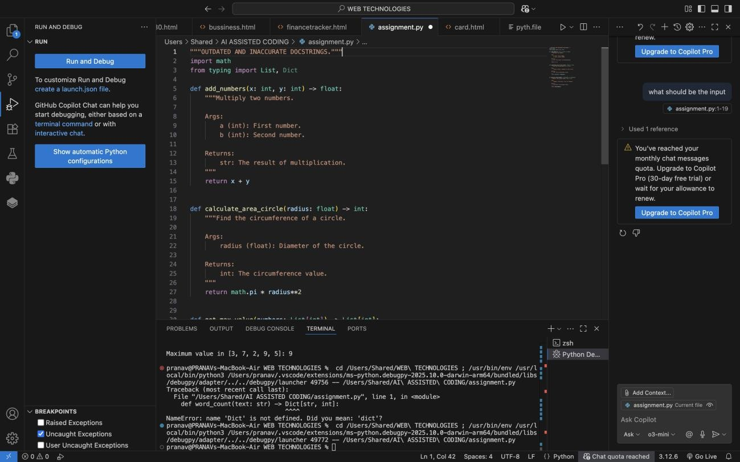

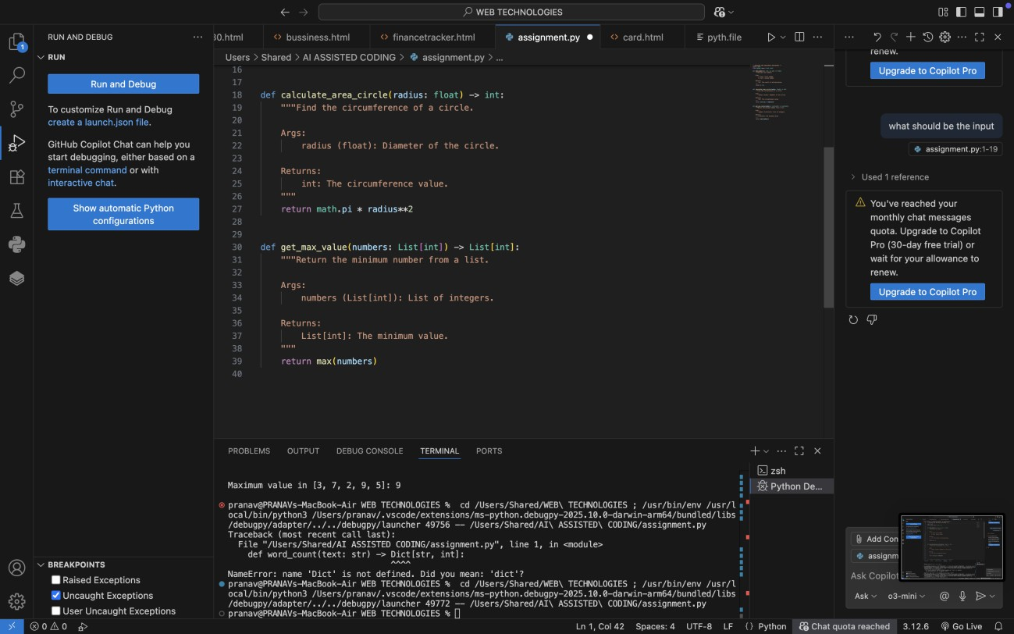
UPDATED DOCSTRING CODE :
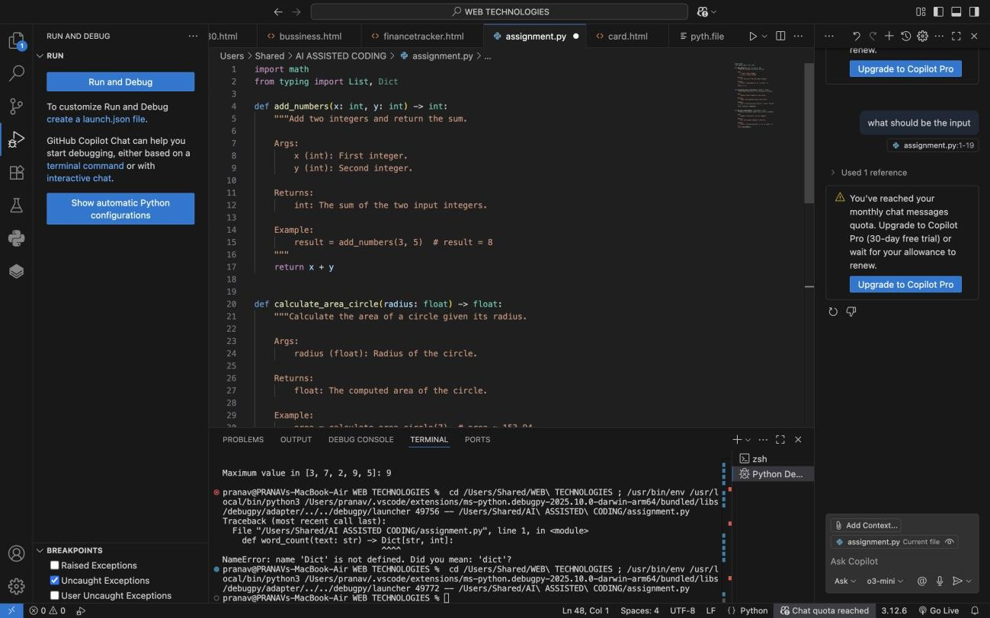

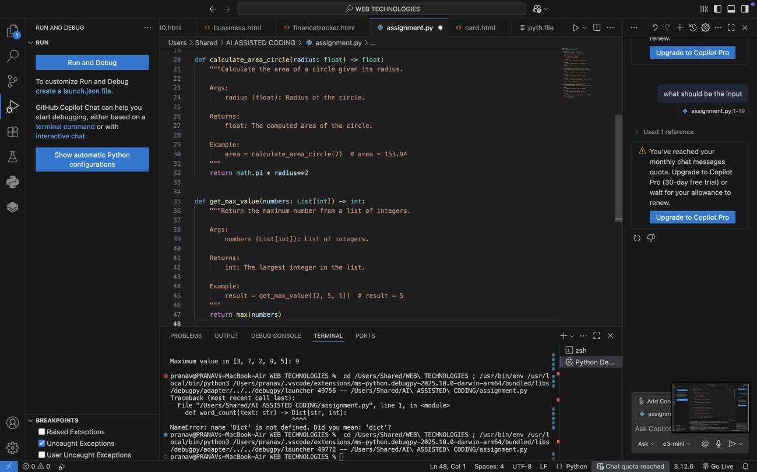
OBSERVATIONS :
The original Python code contained outdated and inaccurate docstrings, which did not correctly describe the actual function behavior.
- Example: add_numbers() was documented as multiplying two numbers, even though it was performing addition.
- Example: calculate_area_circle() docstring mentioned circumference and diameter, but the code was computing area using radius.
- Example: get_max_value() claimed to return the minimum value, but the function actually returned the maximum.
- Parameter names in docstrings (e.g., a, b) did not match the actual function arguments (x, y).
- Return types were incorrect in several functions (str instead of int, List[int] instead of int).
- The corrected version ensures:
  - Accurate function descriptions that match the implemented logic.
  - Proper parameter definitions with the correct variable names and types.
  - Correct return type annotations aligned with actual outputs.
  - Example usage included in each docstring for better clarity.

- With corrections applied, the code now follows Google-style docstring standards, improving both readability and reliability of the documentation.
- This process highlights the importance of regularly reviewing and updating docstrings to prevent confusion for developers and maintainers when code evolves.
Task Description #6 (Documentation – Prompt Comparison Experiment)

Task: Compare documentation output from a vague prompt and a detailed prompt for the same Python function.
- Instructions:
- Create two prompts: one simple (“Add comments to this function”) and one detailed (“Add Google-style docstrings with parameters, return types, and examples”).
- Use AI to process the same Python function with both prompts.
- Analyze and record differences in quality, accuracy, and completeness.
- Expected Output #6:
- A comparison table showing the results from both prompts with observations

PROMPT USED : VAGUE PROMPT :
Add comments to this function to the python code

CODE GENERATED :

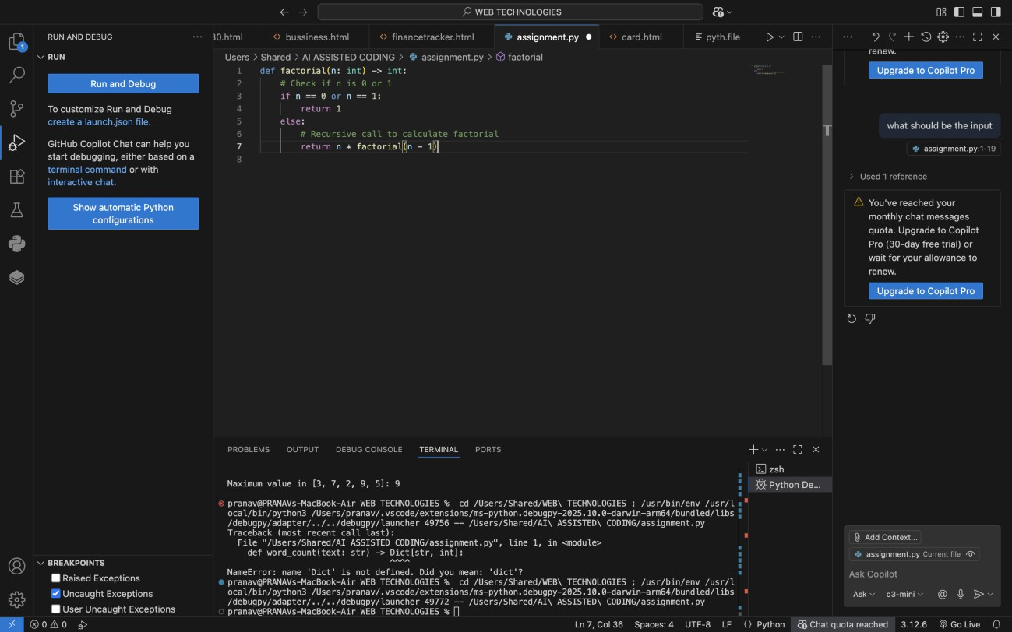

DETAILED PROMPT :
Add Google-style docstrings
with parameters, return types, and examples

CODE GENERATED :

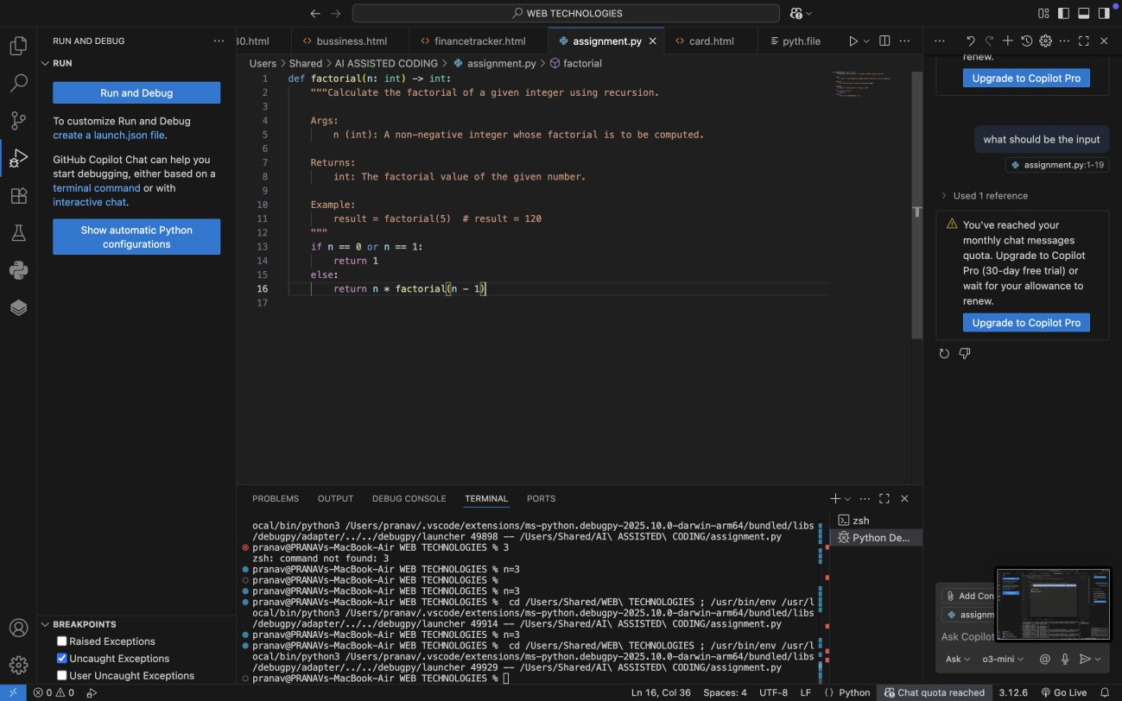
OBSERVATIONS :
  - The vague prompt only produced minimal inline comments, which explain the steps but lack structure, parameter details, return types, or examples.
  - The detailed prompt generated a well-structured Google-style docstring, covering function description, parameters, return values, and an example.
  - Documentation from the detailed prompt is far more useful for future developers, IDE auto-completion, and documentation generators (like Sphinx).
  - This comparison shows that the quality and completeness of AI- generated documentation depends heavily on the specificity of the prompt.

Comparison Table – Vague vs Detailed Prompt

Aspect | Vague Prompt Output | Detailed Prompt Output
Format | Simple inline comments | Structured Google-style docstring
Clarity | Explains basic steps only | Provides clear description of function purpose
Parameters Not documented Includes parameter name, type, and
description

Return Value Example Usage
Not documented Explicitly describes return type and meaning

Not included Provides concrete usage example

Completene ss
Minimal, may confuse new users
Comprehensive, easy for both users and tools to read

Professional ism
  - ​
Looks basic, informal Follows best practices for maintainable code

